LAB 11
Flutter: API integration

API: REST HTTP API (OpenRouter AI)

Openrouter_service.dart
API imports & API Key:
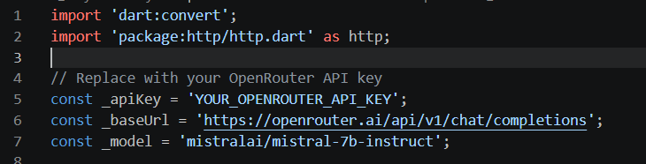
API Key:
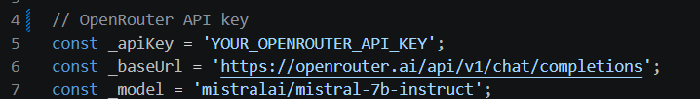

Chat with bot using API
